**EE219 Project 2 – Collaborative Filtering**– *Shubham Mittal* (104774903), *Swati Arora* (404758379), *Anshita Mehrotra* (904743371)

Introduction

A collaborative filtering is a recommender system that refers to methods of predicting a user’s opinion on an entity using other users’ opinion. We predict the users with similar behavior as the target user.

Question 1- Least Square Factorization

A function is defined which takes input R matrix, latent features and maximum iterations for factorization. Matrix Factorization method generates two matrices Rmn = Umk · Vkn , such that each cell in R is generated by dot product of latent vector describing user and a latent vector describing item.

We tested for various values of latent features K= 10, 50, 100 to optimize the sizes of U and V. Following were the results obtained:

Least Squared Error for different latent features

|  |  |  |
| --- | --- | --- |
| Dimension k | Least Squared Error | Iterations |
| 10 | 2.4633e+02 | 100 |
| 50 | 1.7422e+02 | 100 |
| 100 | 1.3170e+02 | 100 |

Question 2 - 10-fold Cross-Validation on Recommendation System

The recommendation system is tested using "10 - fold Cross validation". The data is split randomly as 90 percent training and 10 percent testing across 10 folds (unique test records taken for each fold). Since the best performance was obtained on 100 iterations, all computations were done for k=100. The error is averaged over the 10 folds.

|  |  |
| --- | --- |
| Minimum Error | 0.8924 |
| Maximum Error | 0.9300 |
| Average Absolute Error | 0.9070 |

Question 3 - Recommendation Systems with Threshold Limits

Based on the prediction done in above questions, the data is now classified into two sets that is, if user likes a movie or if he does not like a movie based on the threshold values. If the predicted value is threshold that means the user likes the movie and vice versa. We incremented the threshold by steps of 0.1 and iterated it from 0 to 5. Also, the ROC curves were plotted after a 10-fold cross validation of the data.

Precision vs Recall Curve  
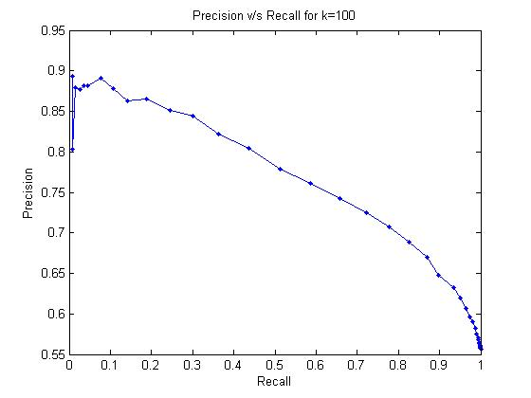

Question 4

Now in Part A of Ques. 4 we apply the same cost function as done in Ques. 1, but this time we reverse the roles of R and W matrices in the factorization step (using the custom_wmnfrule.m file).

Least Squared Error for k = 100: 2.534044e+00

We notice that the least square error has greatly reduced.

We now modify the cost function to add a regularization term lambda (used The regularization implementation was done in regularized_wnmfrule.m). We choose values of lambda to be 0.01, 0.1 and 1.0. The precision and recall was calculated for all lambda values with respect to the latent features and the following curve was obtained. Using regularization, reduced the least square errors and also had a smoothening effect on the curves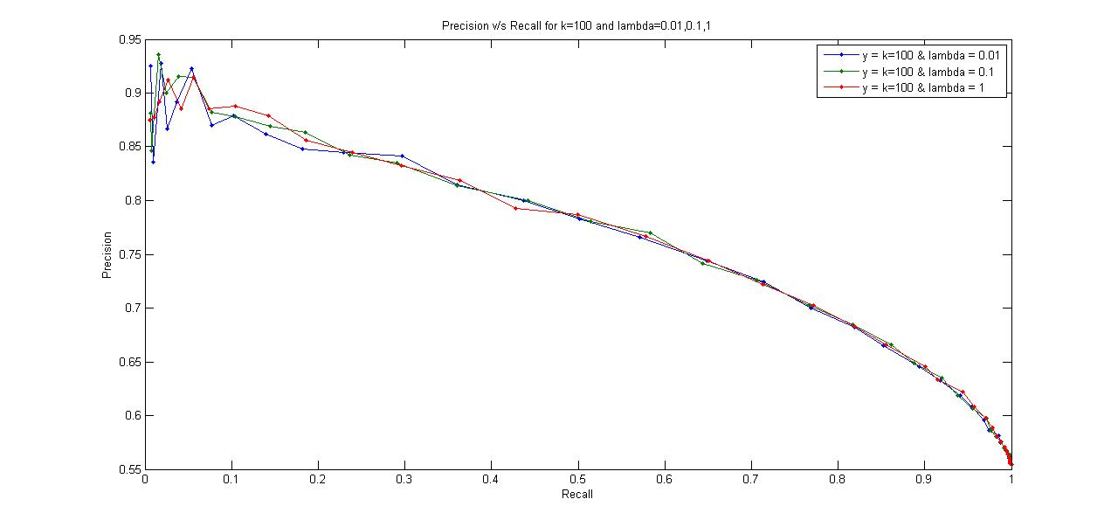

The average absolute errors for (k=100) were:

|  |  |
| --- | --- |
| Lambda | Average absolute error |
| 0.01 | 9.947432 |
| 0.1 | 0.962749 |
| 1 | 7.929945e-01 |

Question 5

For this part, first we find predicted R matrix by supplying R as a 0-1 matrix where 1 is when a rating is available and 0 otherwise. On the other hand, the weight matrix comprised of the actual ratings that the users had given.

While performing a 10 fold cross validation, we kept a track of the predicted ratings corresponding to the known data points. The next step is to sort the ratings for every user in the descending order to get the top L movies for every user.

Hit Rate is the movies recommended by the system which are liked by the user. For this, we calculate the number of movies in L for each user that has a value above threshold. This gives us the hit rate. On the other hand, the movies recommended by the system which are not liked by the user are counted as a false alarm. Thus any rating present in L falling below the threshold which indicates the user did not like it falls under this category. We got different values of Hit Rate and False Alarm Rate by increasing the L from 1 onwards.

When the value of L hit 5, the average precision of the algorithm based on the following formula was calculated:

Precision = 𝑡𝑟𝑢𝑒 𝑝𝑜𝑠𝑖𝑡𝑖𝑣𝑒/ 𝑡𝑟𝑢𝑒 𝑝𝑜𝑠𝑖𝑡𝑖𝑣𝑒 + 𝑓𝑎𝑙𝑠𝑒 𝑝𝑜𝑠𝑖𝑡𝑖𝑣𝑒

The entire process was repeated for k = 10, 50 and 100, and the following results were obtained:

Average precision for L = 5

|  |  |
| --- | --- |
| Dimension of K | Average Precision |
| 10 | 0.531707317073171 |
| 50 | 0.549946977730648 |
| 100 | 0.556945917285261 |

As we can notice, the average precision increases with an increase in the value of k.

The Hit Rate vs False Alarm Rate curve is also an increasing one in such a manner that it approaches 1.

